UNITED STATES
SECURITIES AND EXCHANGE COMMISSION
Washington, D.C. 20549

FORM 6-K

REPORT OF FOREIGN PRIVATE ISSUER
PURSUANT TO RULE 13a-16 OR 15d-16 UNDER
THE SECURITIES EXCHANGE ACT OF 1934

For the month of April 2024

Commission File Number: 001-39407

Li Auto Inc.
(Registrant’s Name)

11 Wenliang Street
Shunyi District, Beijing 101399
People’s Republic of China
(Address of Principal Executive Offices)

Indicate by check mark whether the registrant files or will file annual reports under cover Form 20-F or Form 40-F.

Form 20-F ☒ Form 40-F ☐

EXHIBIT INDEX

Exhibit No. |  | Description
99.1 |  | Li Auto Inc. Launches Li L6, A Five-Seat Premium Family SUV

SIGNATURES

Pursuant to the requirements of the Securities Exchange Act of 1934, the registrant has duly caused this report to be signed on its behalf by the undersigned, thereunto duly authorized.

 | Li Auto Inc.
 | By |  | /s/ Tie Li
 | Name | : | Tie Li
 | Title | : | Director and Chief Financial Officer

Date: April 18, 2024

Exhibit 99.1



Li Auto Inc. Launches Li L6, A Five-Seat Premium Family SUV

April 18, 2024

BEIJING, China, April 18, 2024 — Li Auto Inc. (“Li Auto” or the “Company”) (Nasdaq: LI; HKEX: 2015), a leader in China’s new energy vehicle market, today launched Li L6, a five-seat premium family SUV. Li L6 will offer Pro and Max trims at retail prices of RMB249,800 and RMB279,800, respectively, and will commence deliveries in April 2024.

Below is an overview of Li L6. For more details about Li L6, please visit Li Auto’s official website.

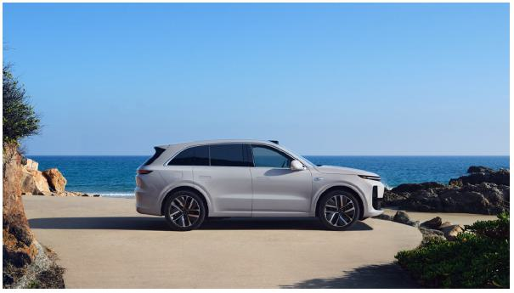

Li L6 is a premium large SUV that offers spacious interior and excellent configurations, with a length of 4,925 millimeters, width of 1,960 millimeters, height of 1,735 millimeters, and wheelbase of 2,920 millimeters. Its standard first-row seats come with a rich array of features, including ventilation, heating, and seat massage with ten acupressure points. The driver enjoys complete control with an adjustable electric steering wheel equipped with heating and grip sensors. Li L6 offers second-row passengers spacious and comfortable ride experience with a maximum of 1,135 millimeters of legroom and 968 millimeters of headroom and configurable features including electric seat adjustment controls, heating for all three seats, and ventilation for two seats, independent air conditioning, a panoramic sunroof with electric sunshade, and a compressor-based refrigerator (standard on Li L6 Max only). Additionally, the trunk of Li L6 is over one meter in depth and features one-click electric folding and reset of the rear seats, providing users with ample and flexible storage space.

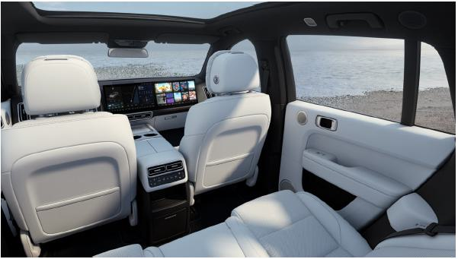

Li L6 excels in both performance and safety. Employing the Company’s range extension system built with the latest generation of lithium iron phosphate battery, Li L6 can support a CLTC range of 1,390 kilometers and a CLTC range of 212 kilometers under EV mode. Equipped with a dual-motor, intelligent, all-wheel drive system in its standard configuration, Li L6 delivers a maximum power of 300 kilowatts allowing the vehicle to accelerate from 0 to 100 kilometers per hour in 5.4 seconds. Its double-wishbone front suspension and five-link rear suspension, working in tandem with a continuous damping control (CDC) system, provide outstanding handling stability and driving comfort. Furthermore, Li L6 is equipped with nine airbags in its standard configuration and has undergone thorough rigorous testing under comprehensive collision scenarios. Combined with its ever-improving AEB active safety system, Li L6 offers robust safety for families on the road.

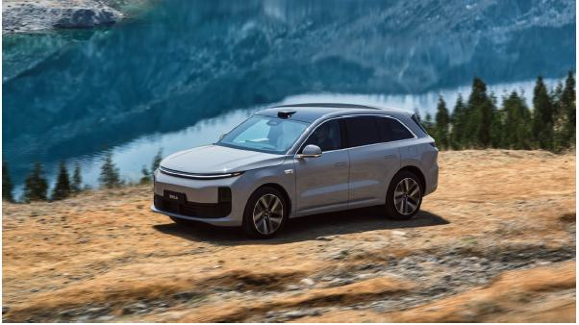

Li L6 offers outstanding smart space and autonomous driving experience. In terms of smart space, both trims come standard with four-screen interaction system powered by the Qualcomm Snapdragon 8295P chip that provides a smooth infotainment user experience. Equipped with Mind GPT, Li Xiang Tong Xue serves as an excellent driving assistant that well understands user needs. In terms of autonomous driving, Li L6 Pro comes standard with Li AD Pro, powered by a Horizon Robotics Journey 5 chip, providing 128 TOPS of computing power, while Li L6 Max comes standard with Li AD Max, powered by dual Orin-X chips, offering 508 TOPS of computing power. Along with the delivery of Li L6, Li AD Pro will be upgraded to Li AD Pro 3.0 and transition to a large model based BEV architecture. Li AD Max 3.0 will be incrementally updated with enhanced advanced autonomous driving capabilities, including the gradual expansion of city NOA coverage to all available roads nationwide. Additionally, the active safety system will also be comprehensively reinforced. The evolution of the Company’s autonomous driving technologies will focus on delivering core user value.

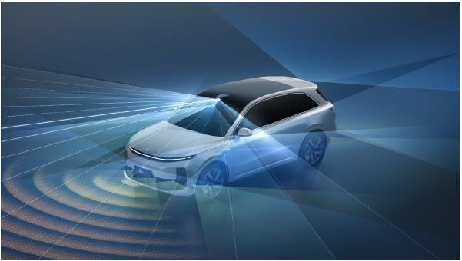

About Li Auto Inc.

Li Auto Inc. is a leader in China’s new energy vehicle market. The Company designs, develops, manufactures, and sells premium smart electric vehicles. Its mission is: Create a Mobile Home, Create Happiness (创造移动的家,创造幸福的家). Through innovations in product, technology, and business model, the Company provides families with safe, convenient, and comfortable products and services. Li Auto is a pioneer to successfully commercialize extended-range electric vehicles in China. The Company started volume production in November 2019. Its current model lineup includes Li MEGA, a high-tech flagship family MPV, Li L9, a six-seat flagship family SUV, Li L8, a six-seat premium family SUV, Li L7, a five-seat flagship family SUV, and Li L6, a five-seat premium family SUV. The Company leverages technology to create value for its users. It concentrates its in-house development efforts on its proprietary range extension system, next-generation electric vehicle technology, and smart vehicle solutions while expanding its product line by developing new BEVs and EREVs to target a broader user base.

For more information, please visit: https://ir.lixiang.com.

Safe Harbor Statement

This press release contains statements that may constitute “forward-looking” statements pursuant to the “safe harbor” provisions of the U.S. Private Securities Litigation Reform Act of 1995. These forward-looking statements can be identified by terminology such as “will,” “expects,” “anticipates,” “aims,” “future,” “intends,” “plans,” “believes,” “estimates,” “targets,” “likely to,” “challenges,” and similar statements. Li Auto may also make written or oral forward-looking statements in its periodic reports to the U.S. Securities and Exchange Commission (the “SEC”) and The Stock Exchange of Hong Kong Limited (the “HKEX”), in its annual report to shareholders, in press releases and other written materials, and in oral statements made by its officers, directors, or employees to third parties. Statements that are not historical facts, including statements about Li Auto’s beliefs, plans, and expectations, are forward-looking statements. Forward-looking statements involve inherent risks and uncertainties. A number of factors could cause actual results to differ materially from those contained in any forward-looking statement, including but not limited to the following: Li Auto’s strategies, future business development, and financial condition and results of operations; Li Auto’s limited operating history; risks associated with extended-range electric vehicles and high-power charging battery electric vehicles; Li Auto’s ability to develop, manufacture, and deliver vehicles of high quality and appeal to customers; Li Auto’s ability to generate positive cash flow and profits; product defects or any other failure of vehicles to perform as expected; Li Auto’s ability to compete successfully; Li Auto’s ability to build its brand and withstand negative publicity; cancellation of orders for Li Auto’s vehicles; Li Auto’s ability to develop new vehicles; and changes in consumer demand and government incentives, subsidies, or other favorable government policies. Further information regarding these and other risks is included in Li Auto’s filings with the SEC and the HKEX. All information provided in this press release is as of the date of this press release, and Li Auto does not undertake any obligation to update any forward-looking statement, except as required under applicable law.

For investor and media inquiries, please contact:

Li Auto Inc.
Investor Relations
Email: ir@lixiang.com

Piacente Financial Communications
Brandi Piacente
Tel: +1-212-481-2050
+86-10-6508-0677
Email: Li@tpg-ir.com

