UNITED STATES
SECURITIES AND EXCHANGE COMMISSION
Washington, D.C. 20549

FORM 6-K

REPORT OF FOREIGN PRIVATE ISSUER
PURSUANT TO RULE 13a-16 OR 15d-16 UNDER
THE SECURITIES EXCHANGE ACT OF 1934

For the month of August 2026

Commission File Number: 001-39407

Li Auto Inc.
(Registrant’s Name)

11 Wenliang Street
Shunyi District, Beijing 101399
People’s Republic of China
(Address of Principal Executive Offices)

Indicate by check mark whether the registrant files or will file annual reports under cover Form 20-F or Form 40-F.

Form 20-F ☒ Form 40-F ☐

EXHIBIT INDEX

Exhibit No. |  | Description
99.1 |  | Next Day Disclosure Return dated August 17, 2026
99.2 |  | Next Day Disclosure Return dated August 18, 2026
99.3 |  | Next Day Disclosure Return dated August 19, 2026
99.4 |  | Next Day Disclosure Return dated August 20, 2026

SIGNATURES

Pursuant to the requirements of the Securities Exchange Act of 1934, the registrant has duly caused this report to be signed on its behalf by the undersigned, thereunto duly authorized.

 | Li Auto Inc.
 | By |  | /s/ Tie Li
 | Name | : | Tie Li
 | Title | : | Director and Chief Financial Officer

Date: August 24, 2026

Exhibit 99.1
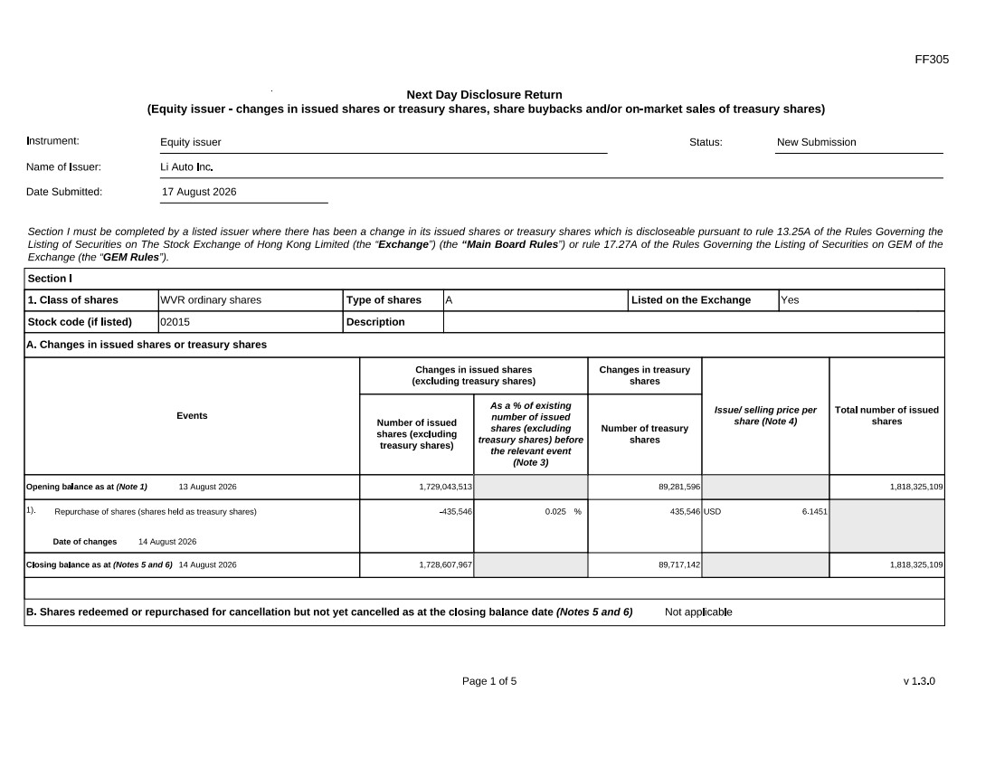
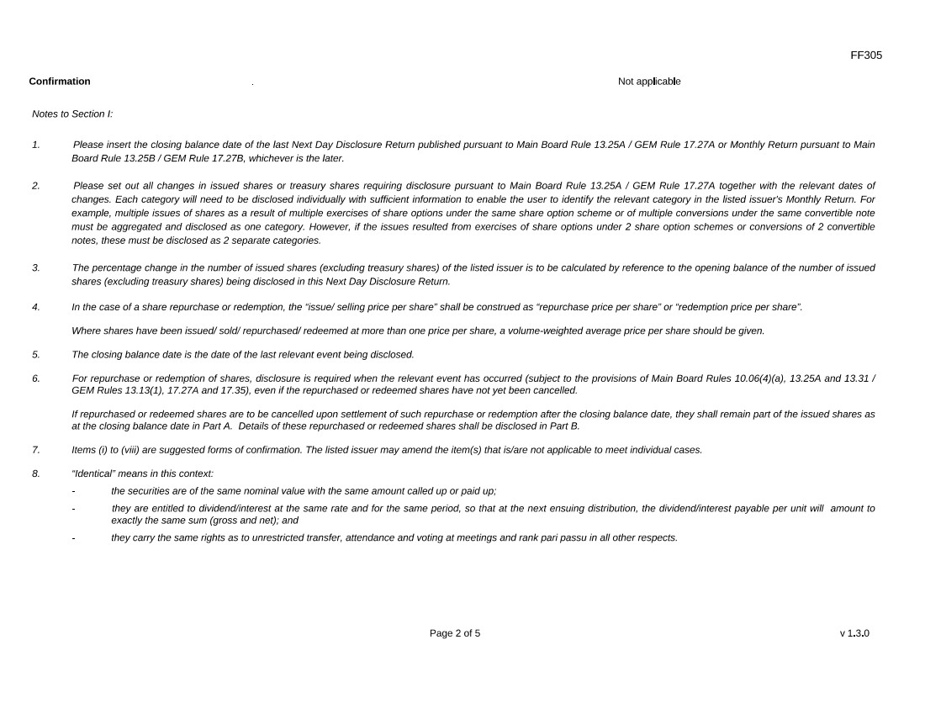
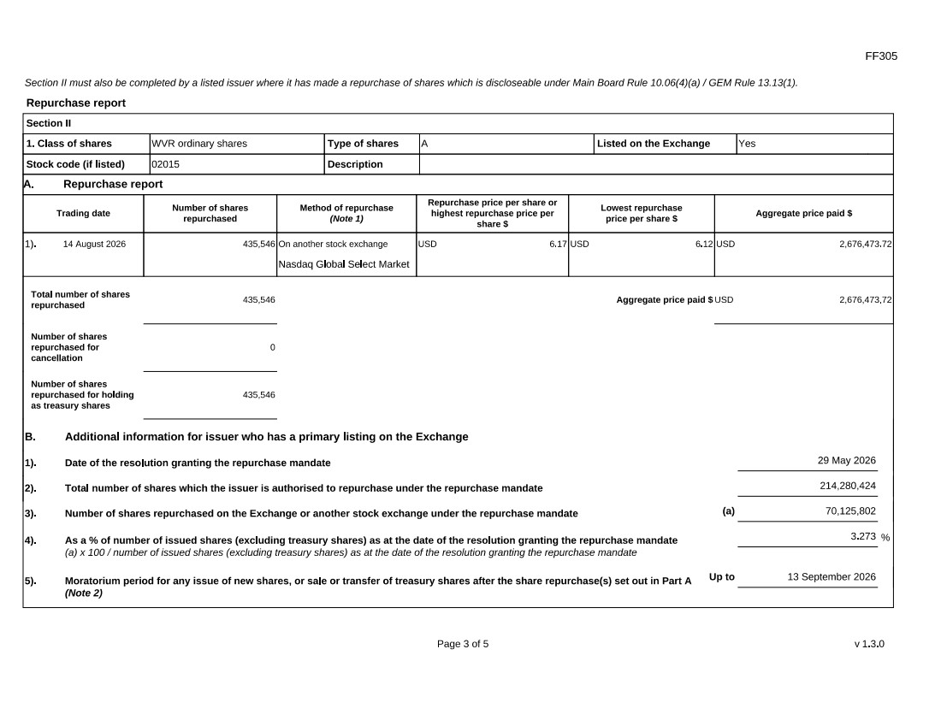
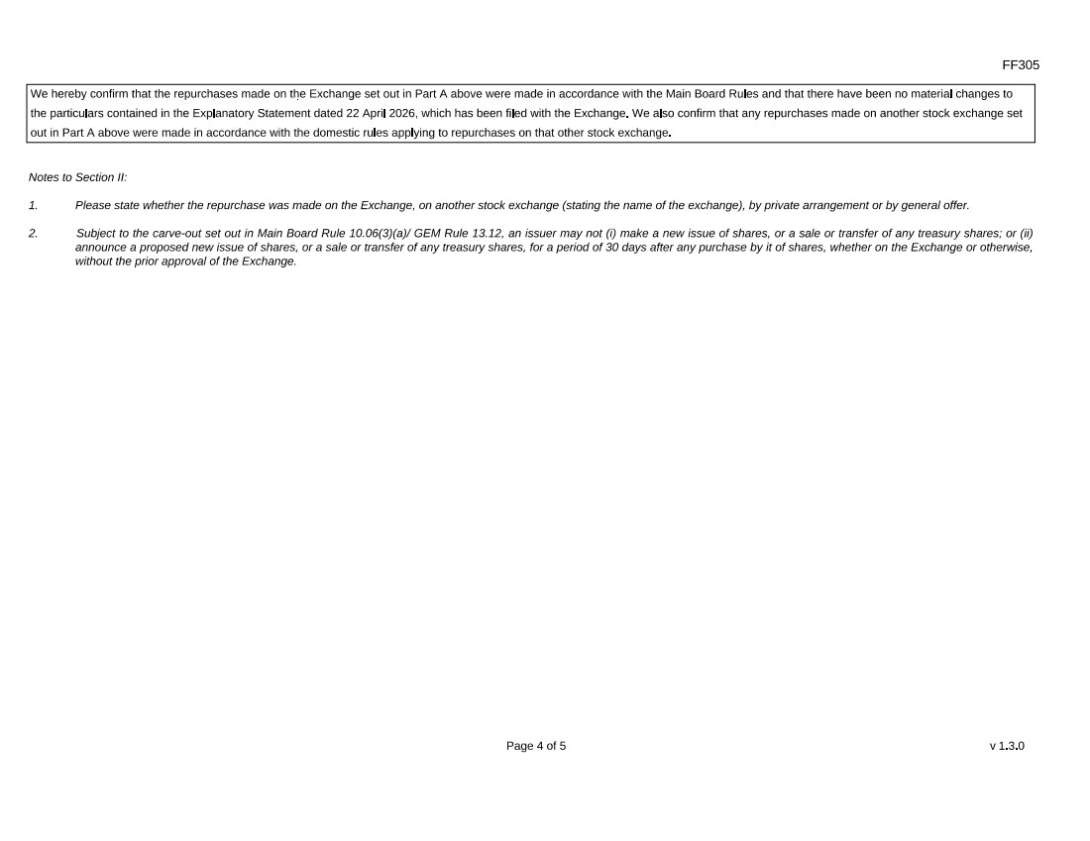
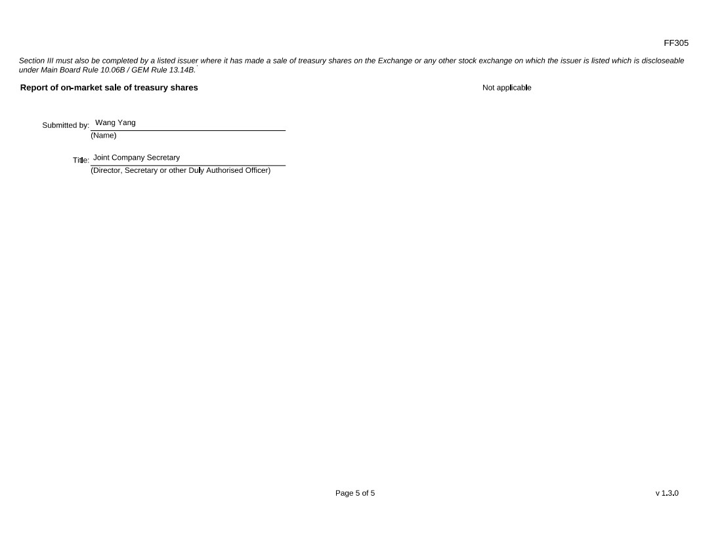
Exhibit 99.2
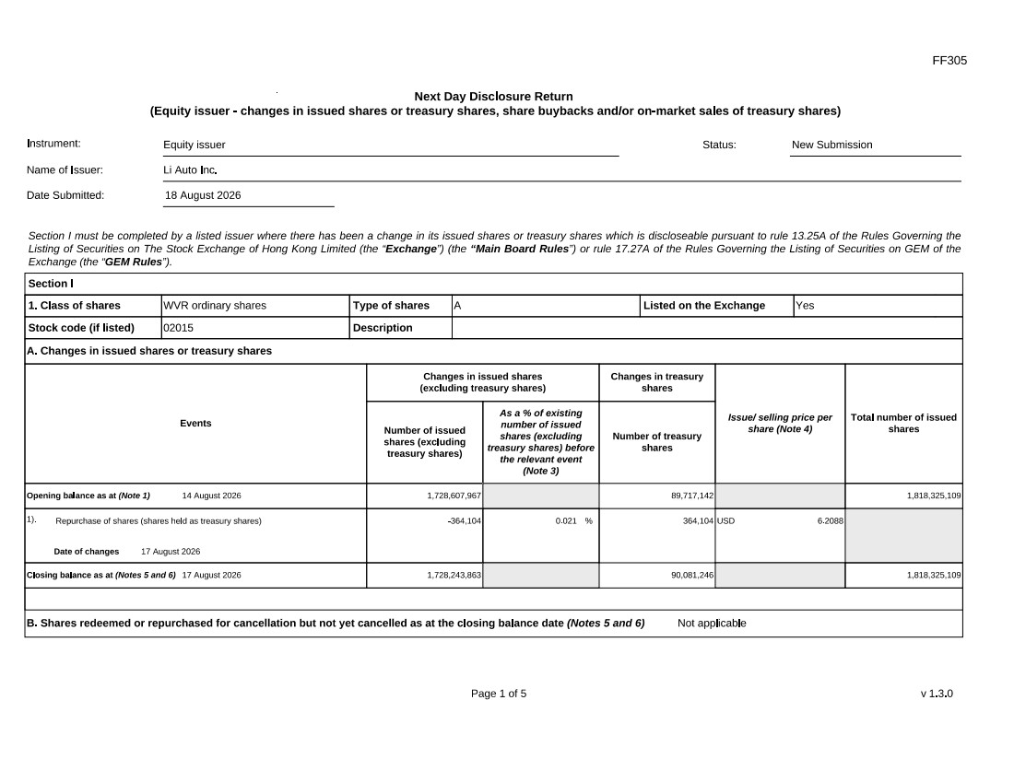
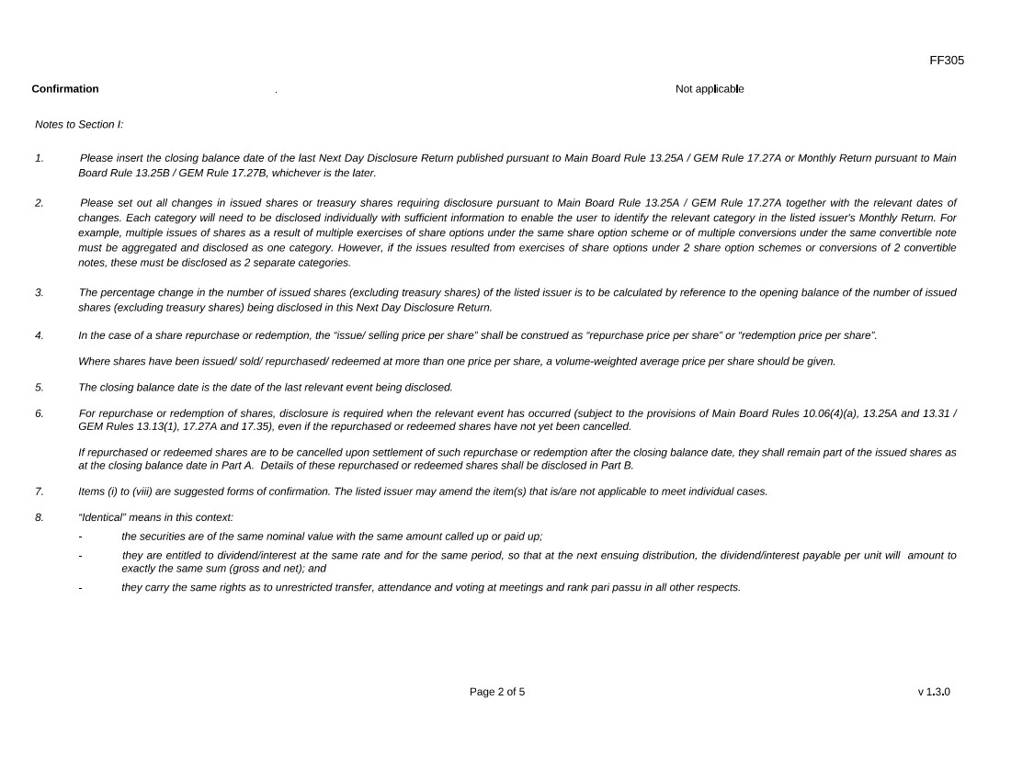
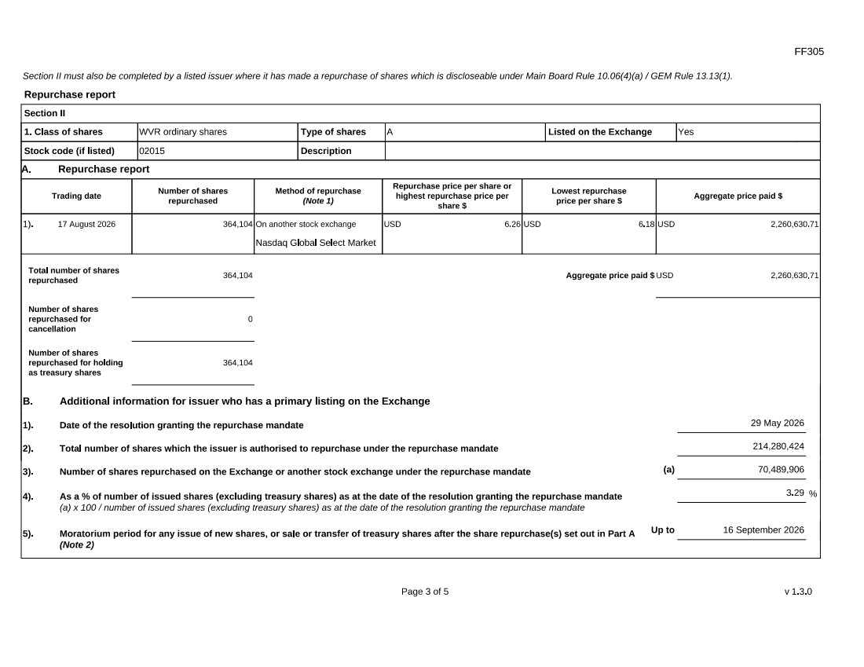
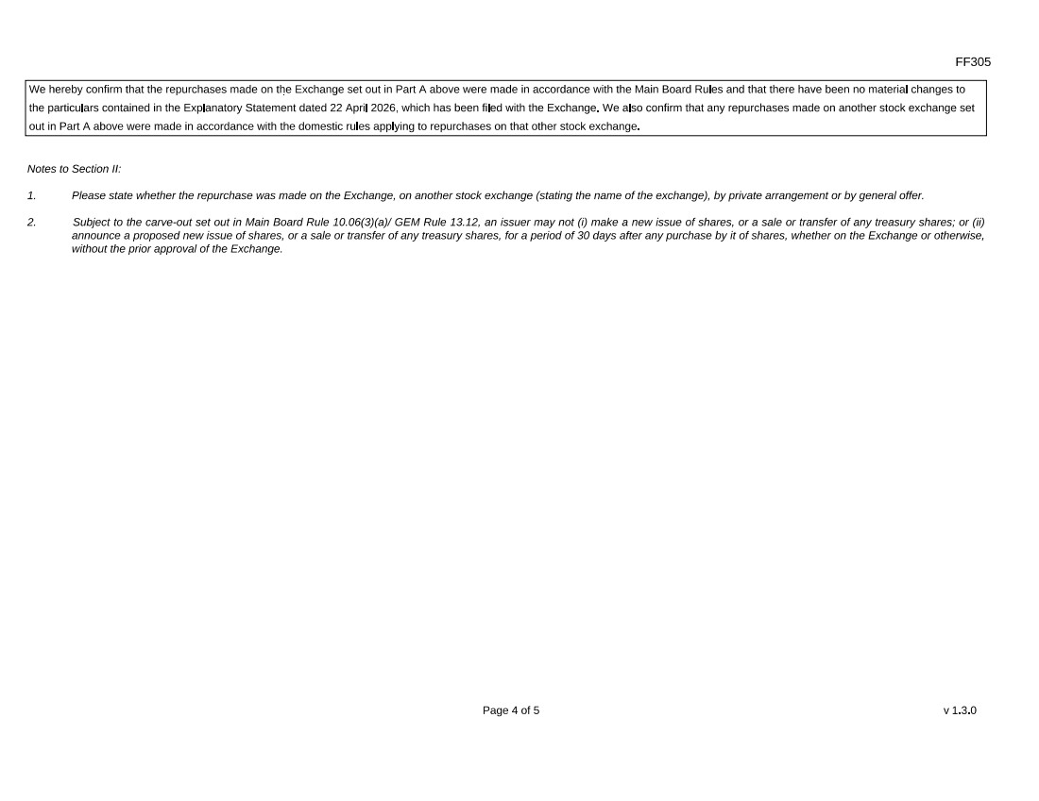
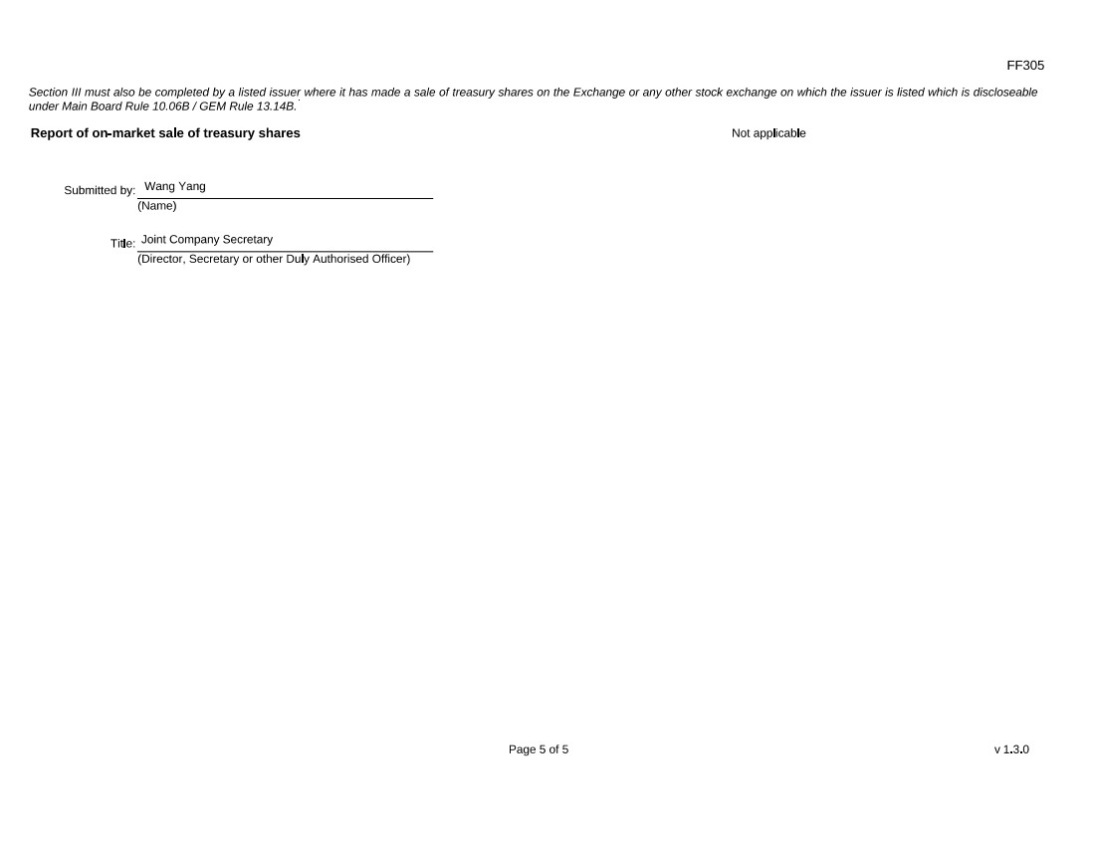
Exhibit 99.3
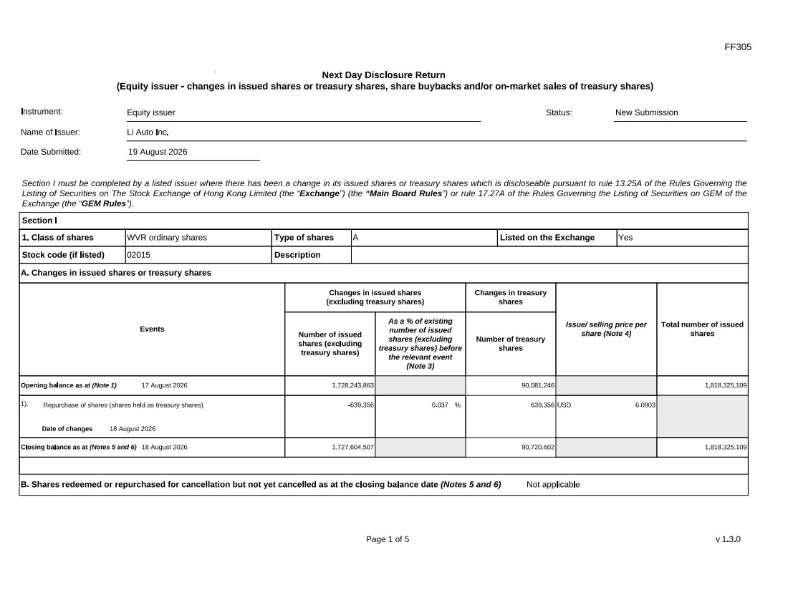
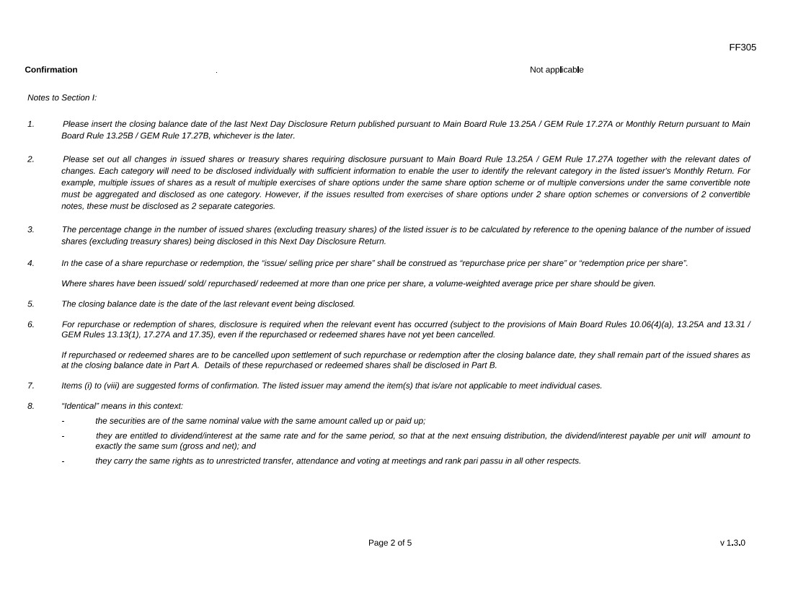
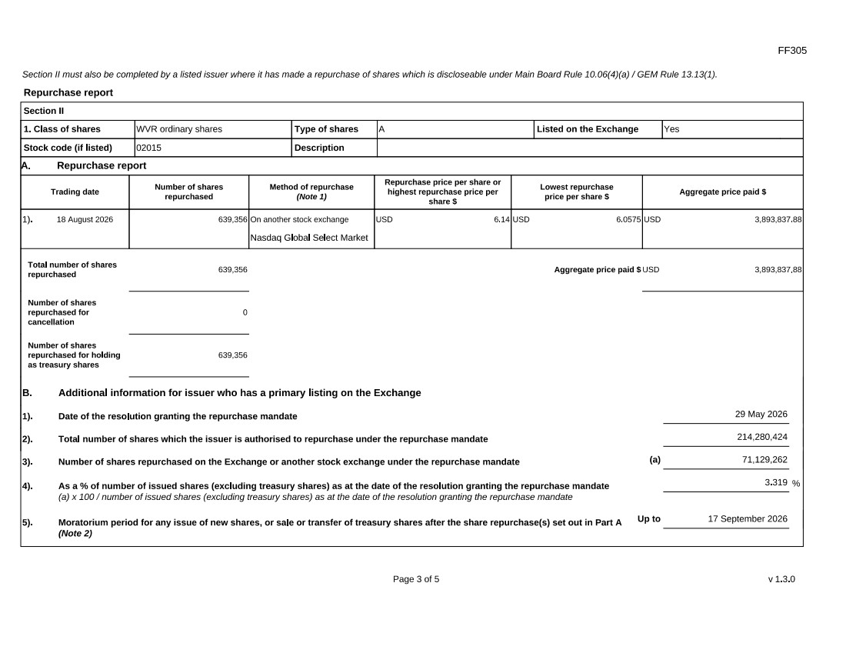
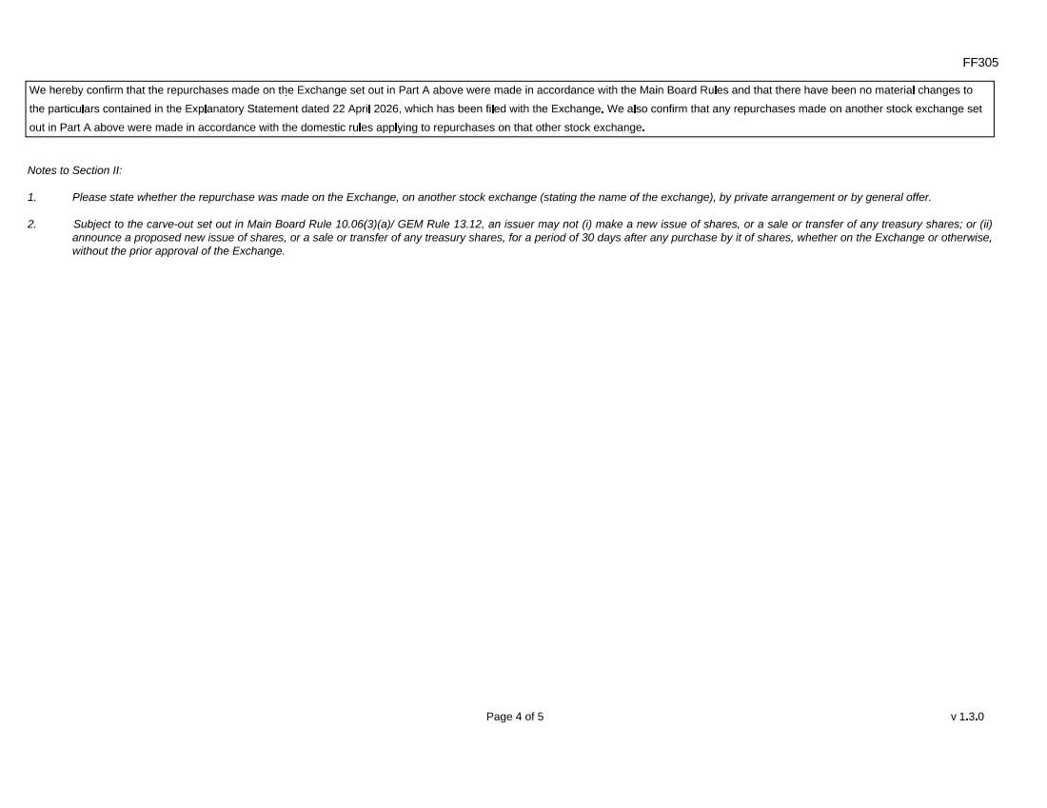
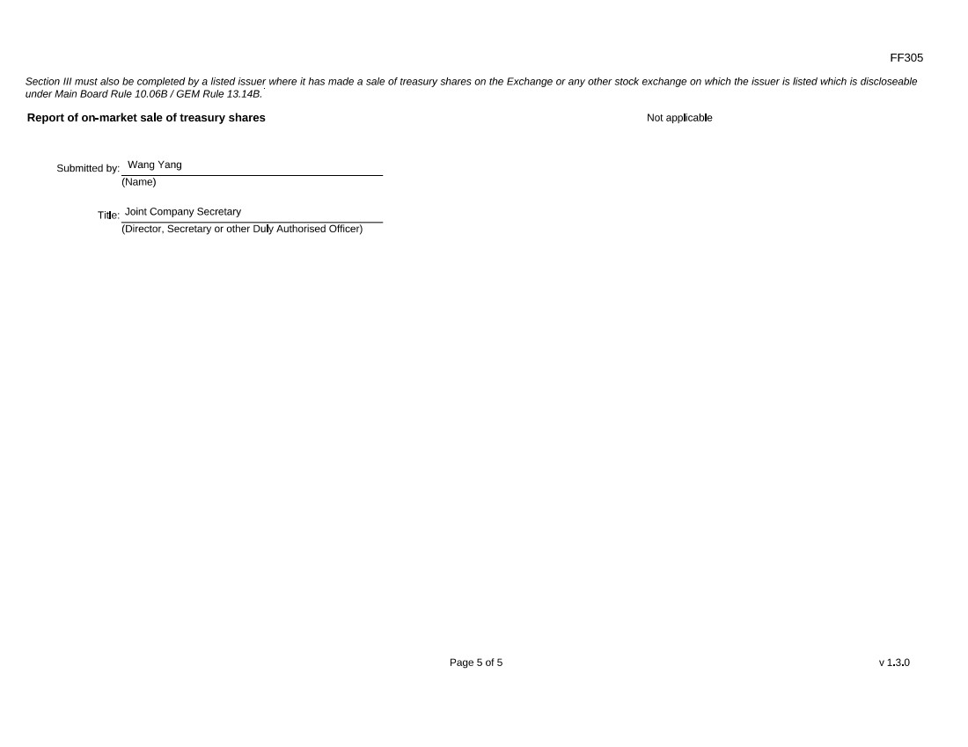
Exhibit 99.4


