UNITED STATES

SECURITIES AND EXCHANGE COMMISSION

Washington, D.C. 20549

FORM 6-K

REPORT OF FOREIGN PRIVATE ISSUER

PURSUANT TO RULE 13a-16 OR 15d-16 UNDER

THE SECURITIES EXCHANGE ACT OF 1934

For the month of June 2026

Commission File Number: 001-39407

Li Auto Inc.

(Registrant’s Name)

11 Wenliang Street

Shunyi District, Beijing 101399

People’s Republic of China

(Address of Principal Executive Offices)

Indicate by check mark whether the registrant files or will file annual reports under cover Form 20-F or Form 40-F.

Form 20-F ☒ Form 40-F o

 |  |  |  |  |  | EXHIBIT INDEX
 | Exhibit No. |  |  |  |  | Description
 |  | 99.1 |  |  | Next Day Disclosure Return dated June 22, 2026
 |  | 99.2 |  |  | Next Day Disclosure Return dated June 24, 2026
 |  | 99.3 |  |  | Next Day Disclosure Return dated June 25, 2026
 |  | 99.4 |  |  | Next Day Disclosure Return dated June 26, 2026

SIGNATURES

Pursuant to the requirements of the Securities Exchange Act of 1934, the registrant has duly caused this report to be signed on its behalf by the undersigned, thereunto duly authorized.

Li Auto Inc.

By |  | /s/ Tie Li
Name | : | Tie Li
Title | : | Director and Chief Financial Officer

Date: June 29, 2026

Exhibit 99.1
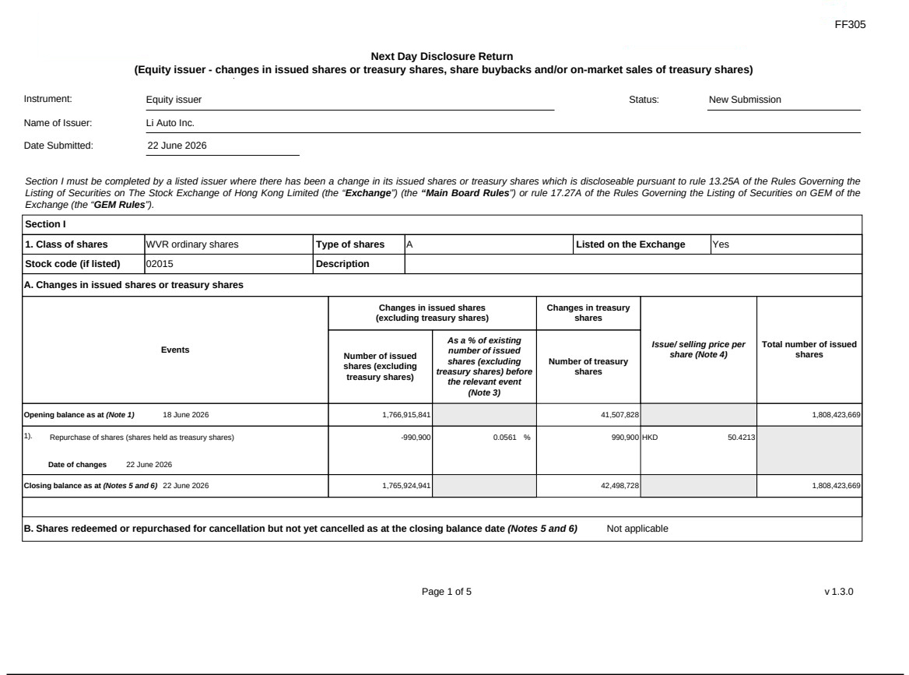

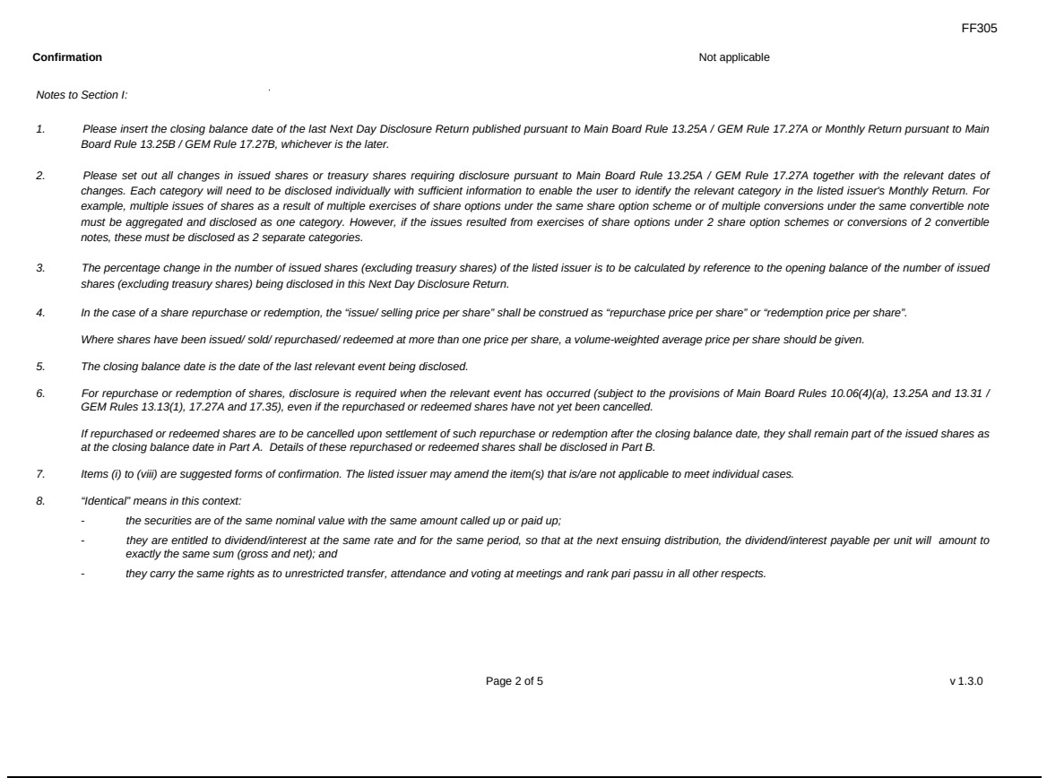

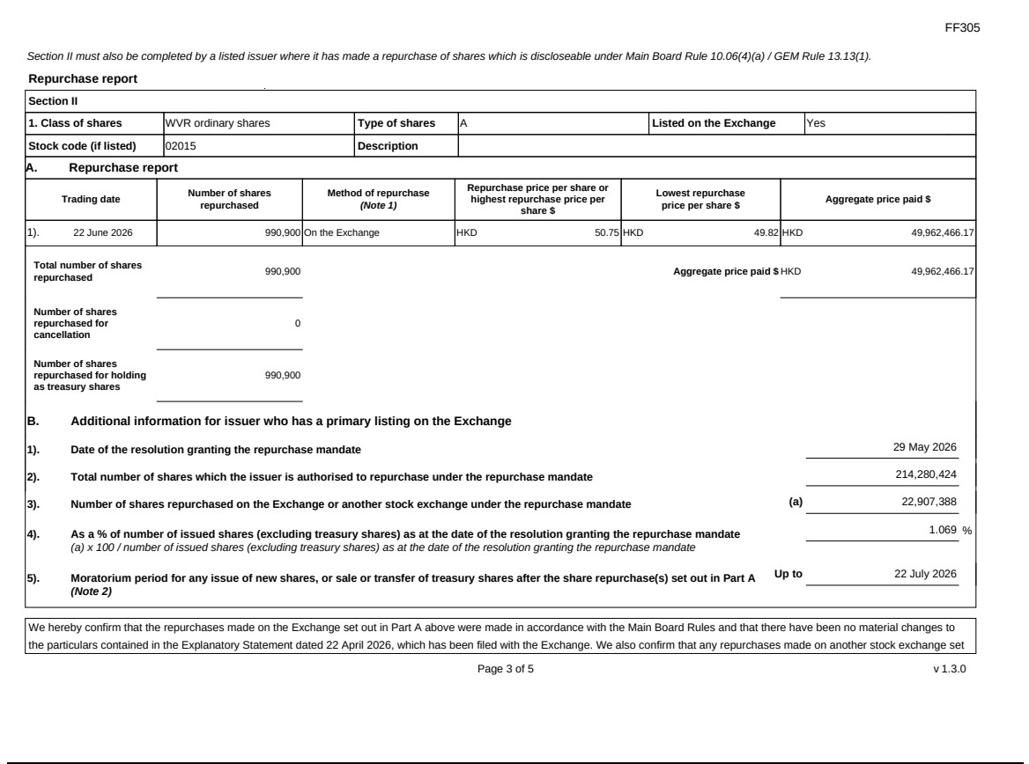

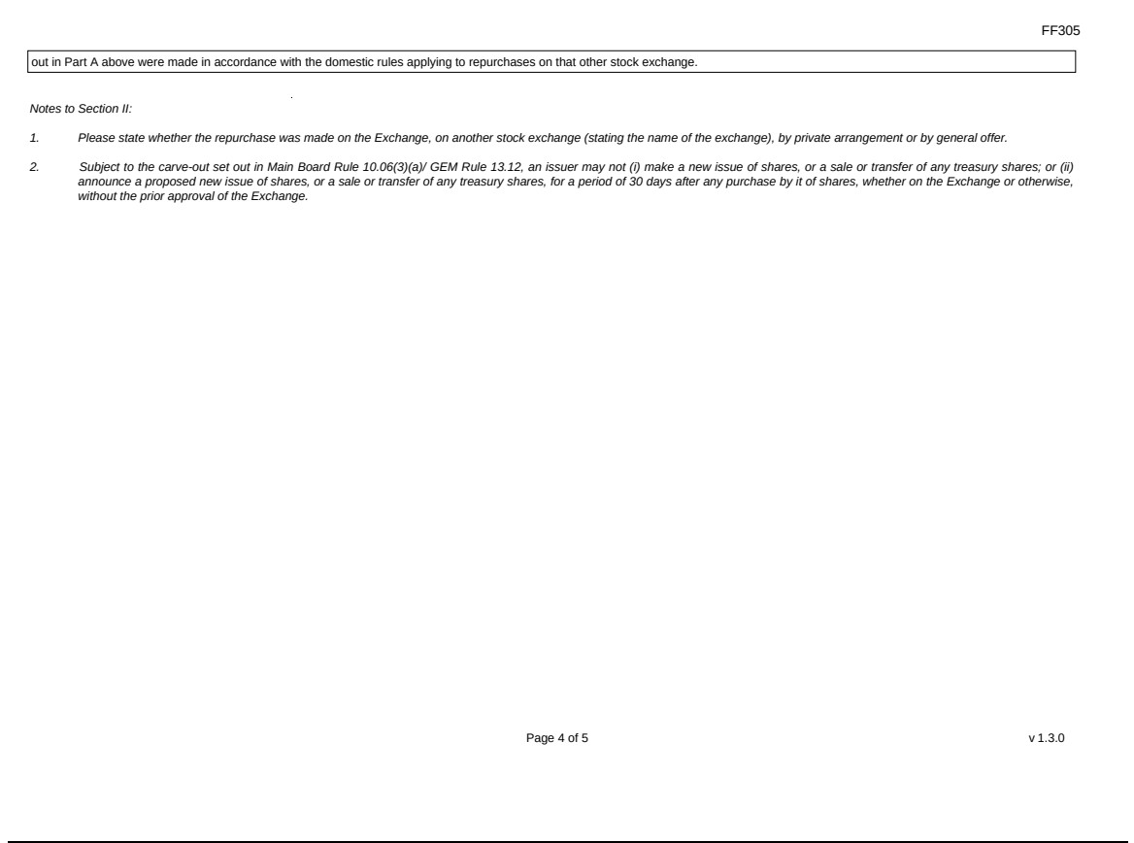

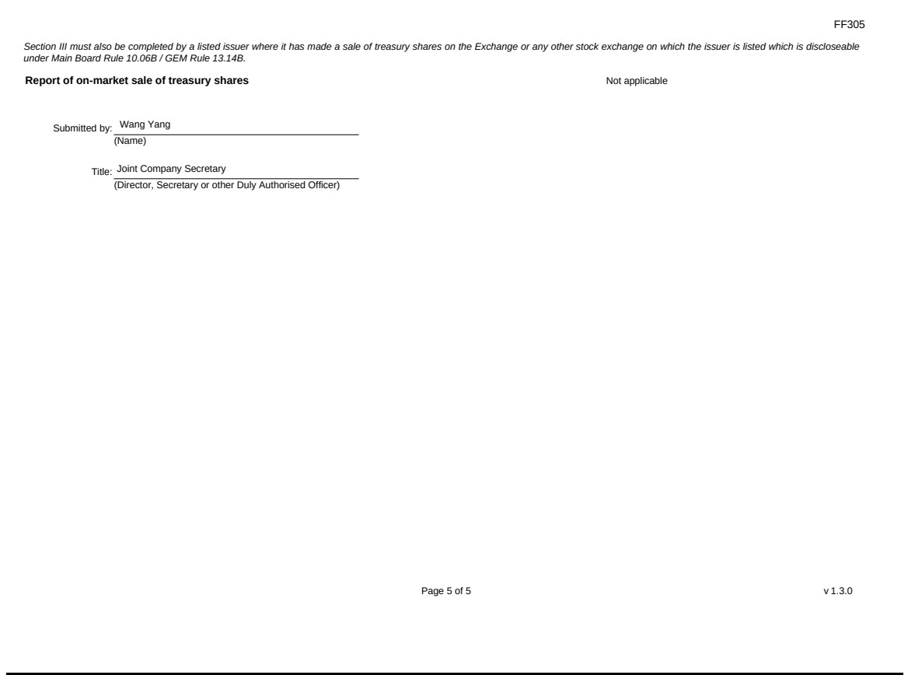

Exhibit 99.2
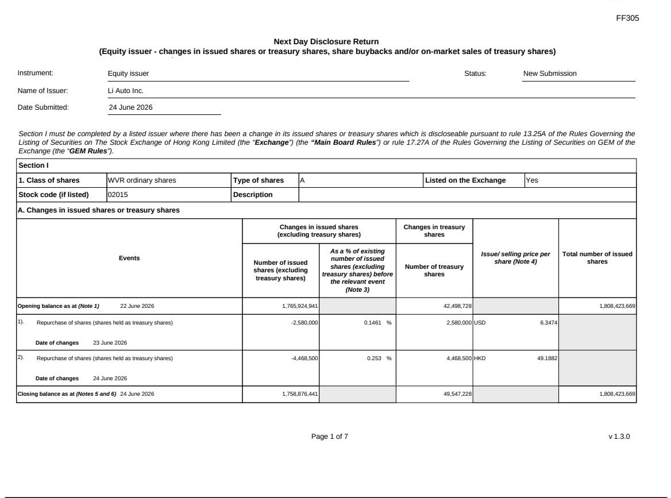

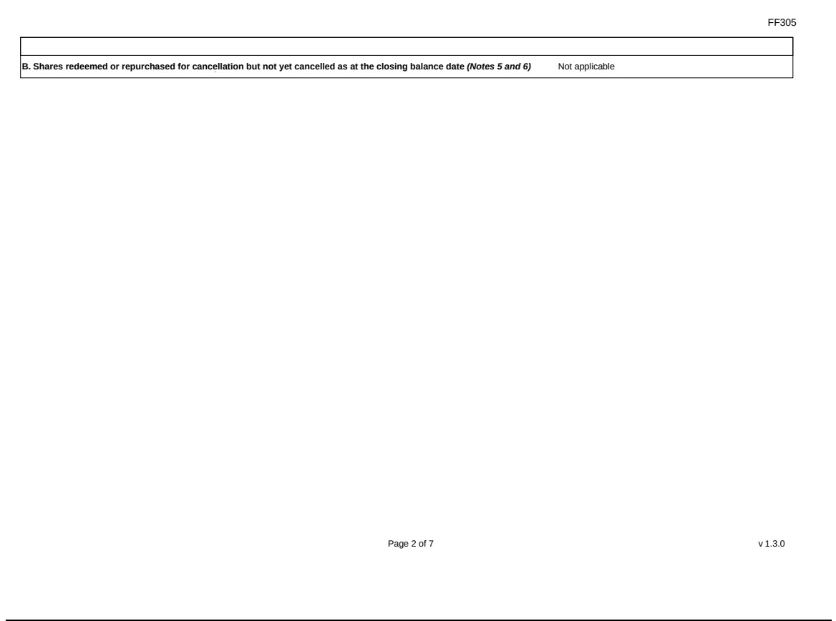

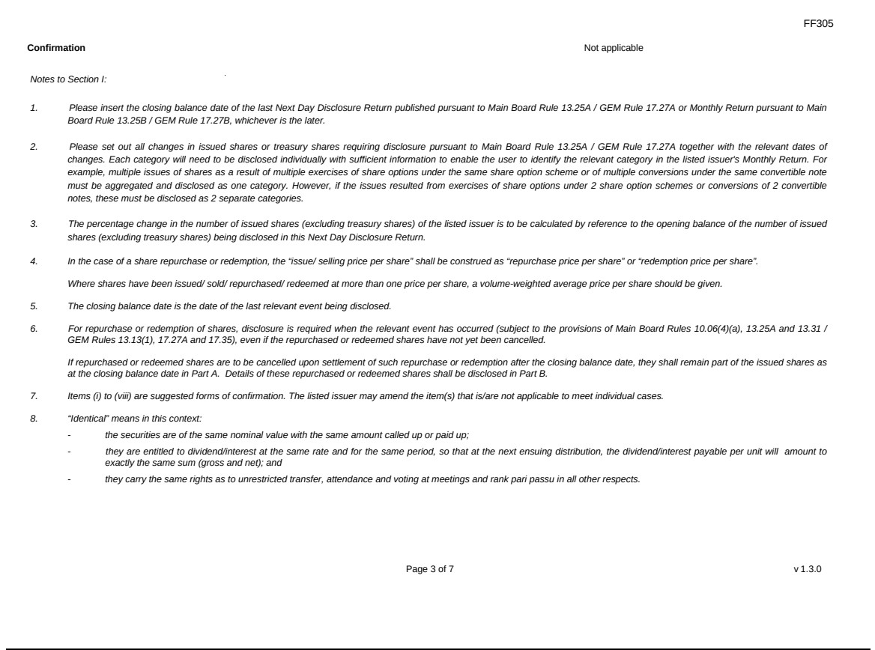

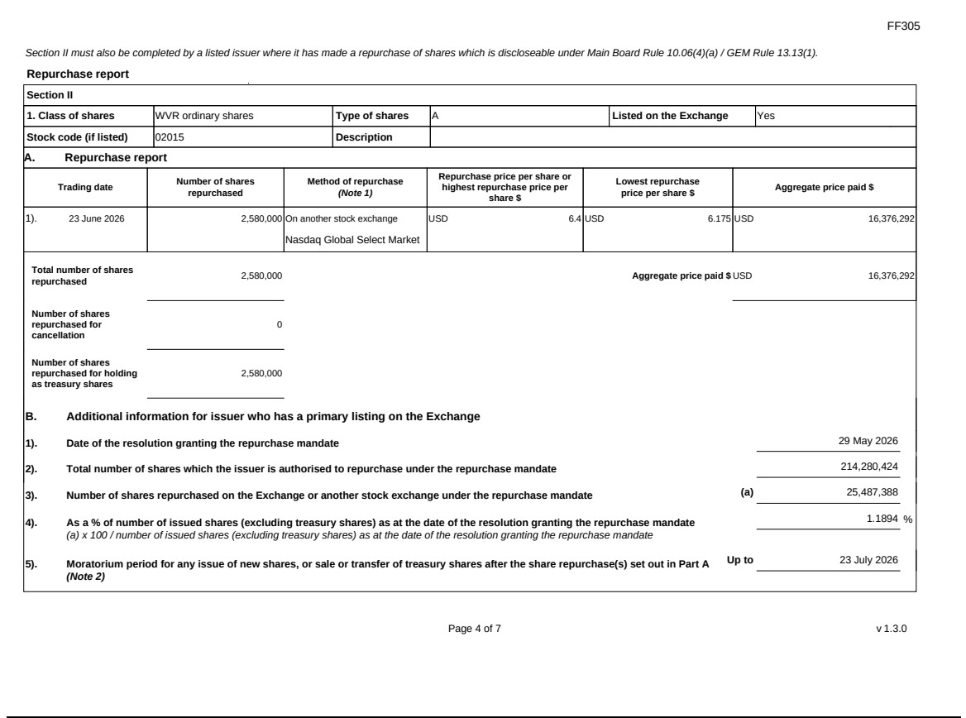

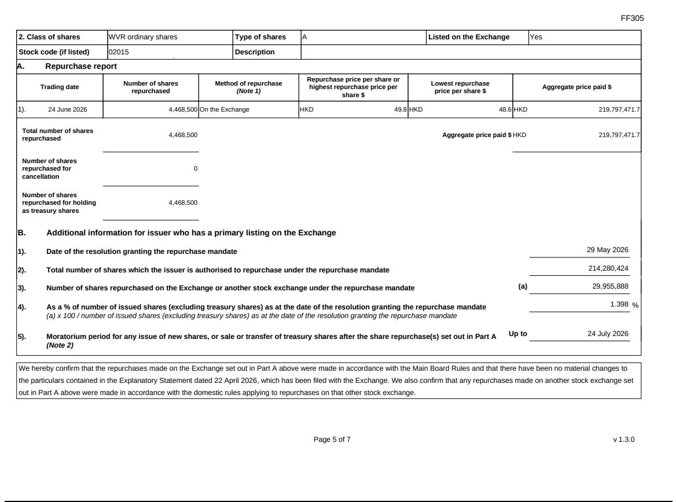

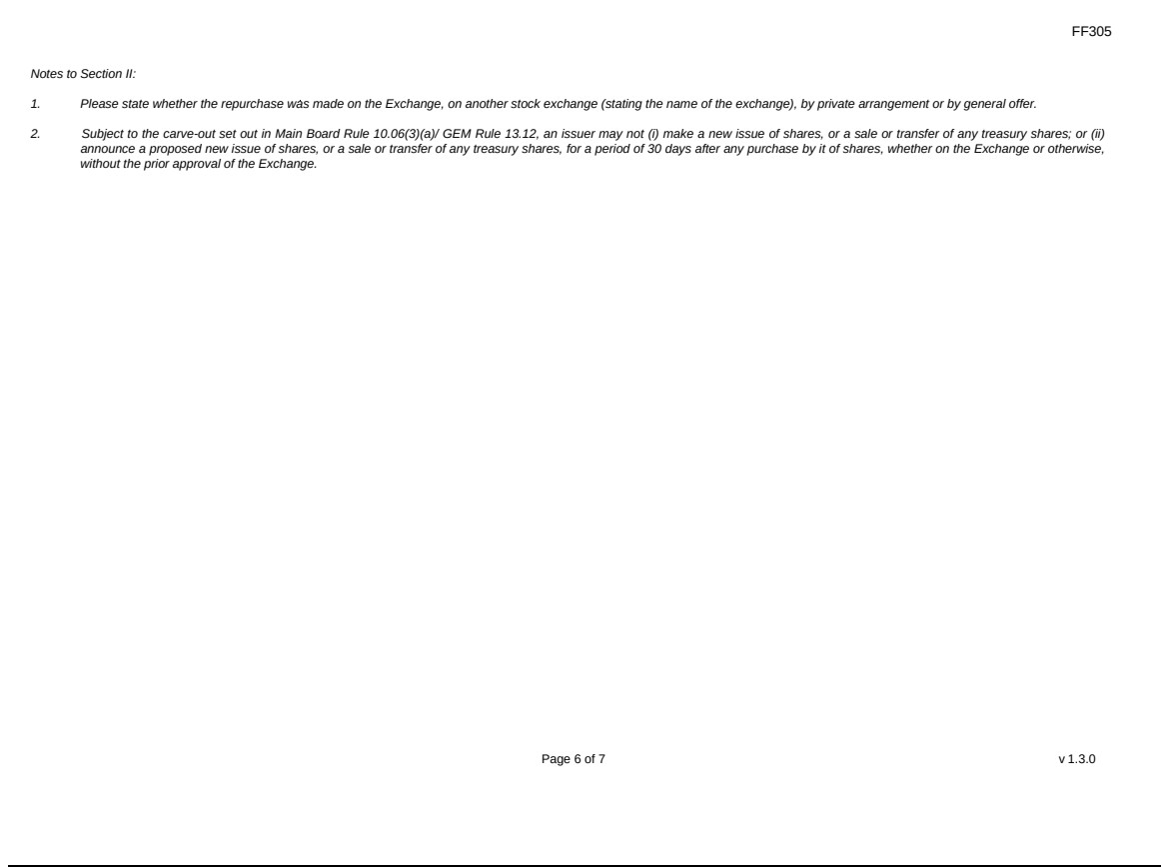

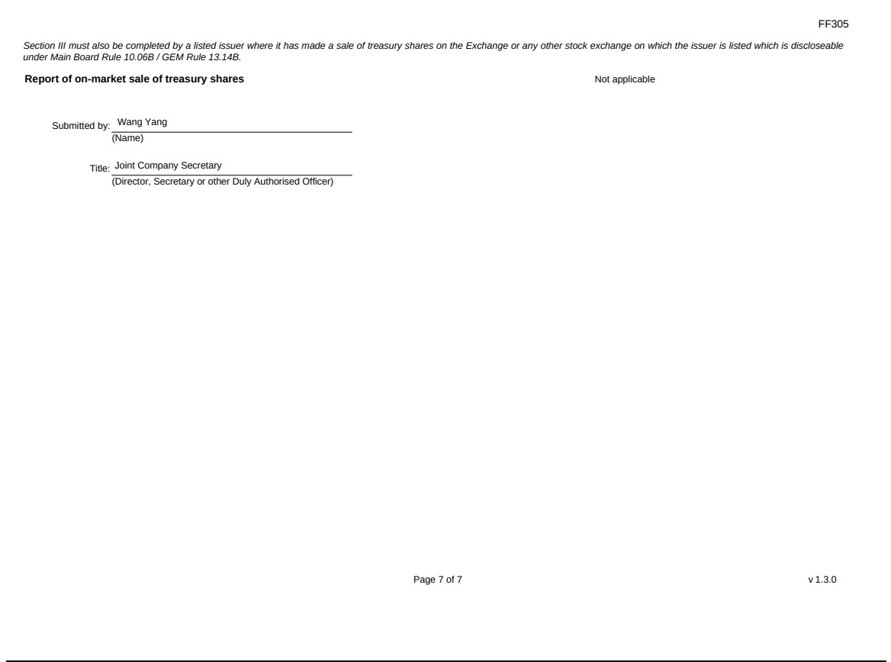

Exhibit 99.3
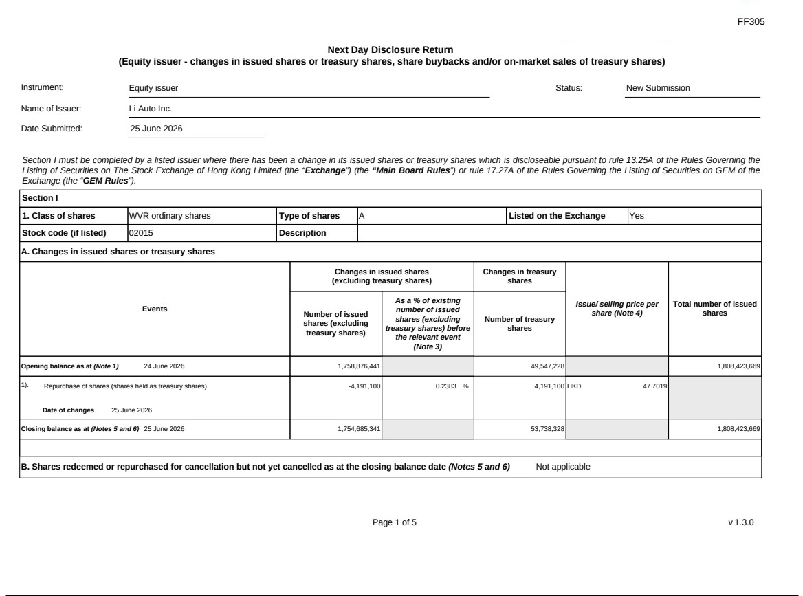

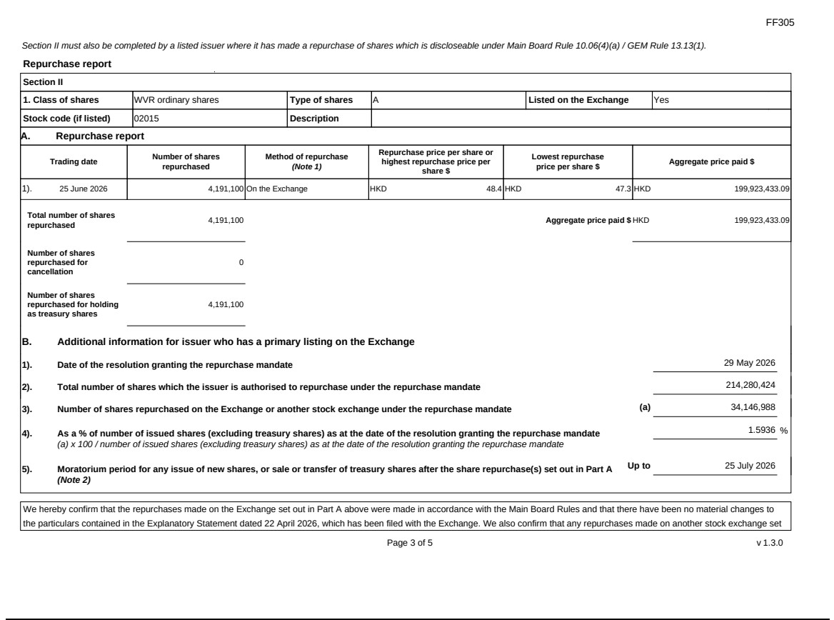

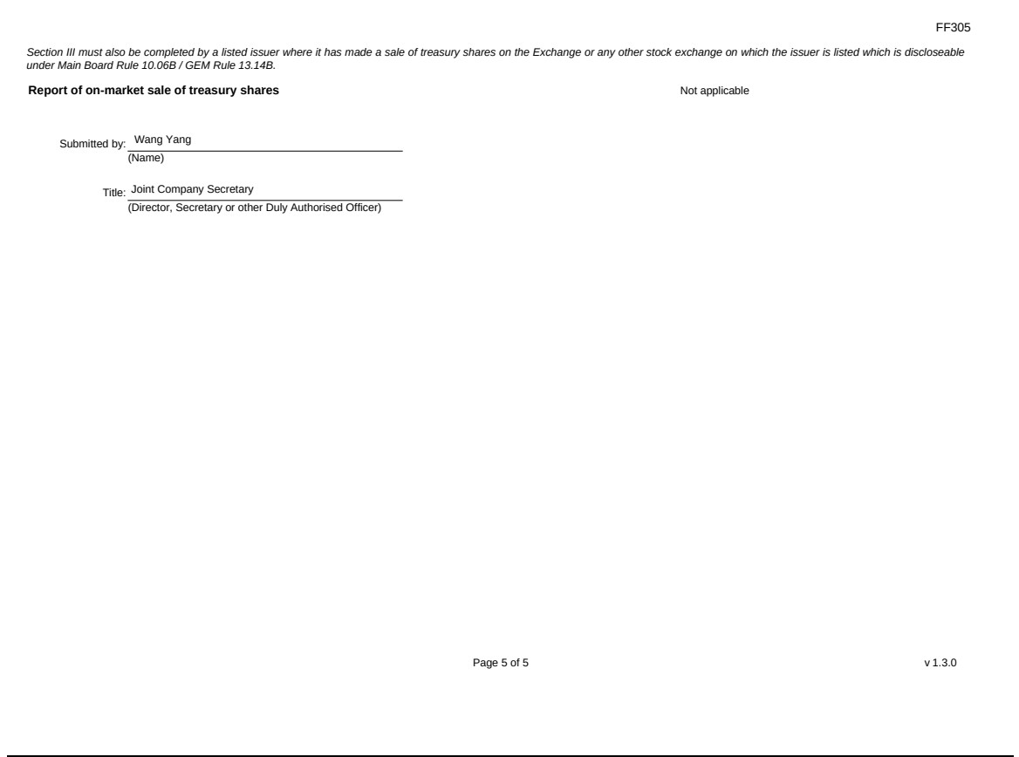

Exhibit 99.4


